Information

Model = Goldbeter

t0 = 0; t1 = 20; dt = 0.001;

dx = 1e-3;

x = 0:dx:1;

mtol = 1e-6;

odeoptions = odeset('RelTol', 1e-6, 'AbsTol', 1e-6);

Z_0 = 0.5; V_0 = -40; Y_0 = 0.5;

D = 6e-6;

Fickian Diffusion – Linear d $β$ dx

beta = 0: 1e-3:1;

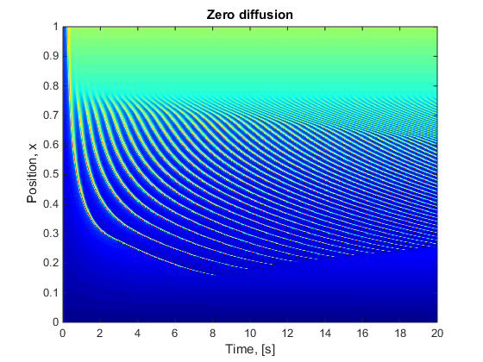

Position depth = 0.16

Beta depth = 0.16 $±$ 0.001

Fickian Diffusion – Change to d $β$ dx

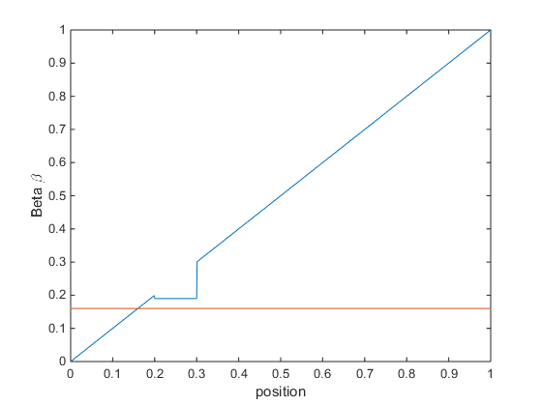

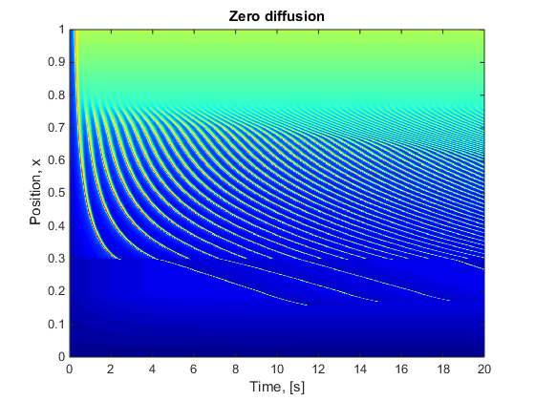

Position depth = 0.3

Beta Depth= 0.19